Using EMIT “Colour” for small NWO events

The Colour software is designed for small colour coded events. There is a similar program available for age related events.
Martin Light has access to the BOF membership data and can update it in the event software.

Running the Colour Software

The software is run from G:\ecolour\CLR.Exe
Either Double click on the icon named COLOUR (or COLOUR.BAT) on the desktop
Main Screen will open
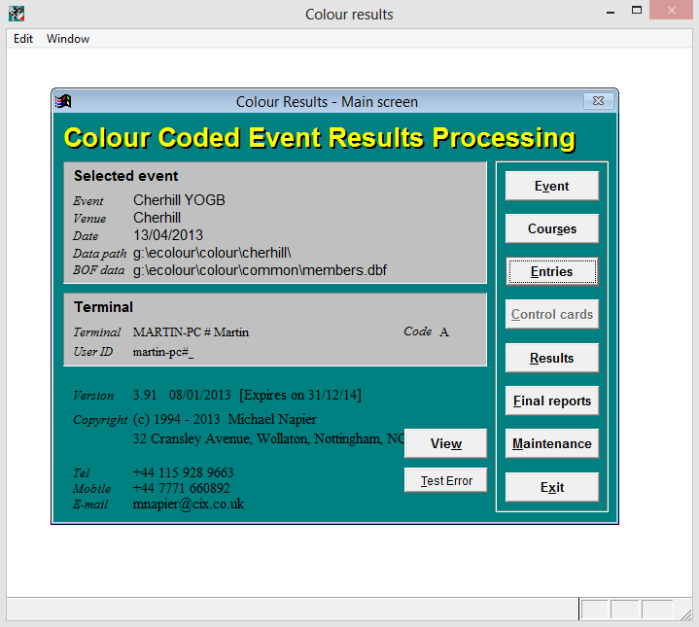
NB Unlike most Windows programs it cannot be shut down using the X at the top right of the window.
To shutdown the software keep clicking on Exit, until finally clicking Exit on the Main Screen will close the program.

Creating a new event

Click on Event and then New
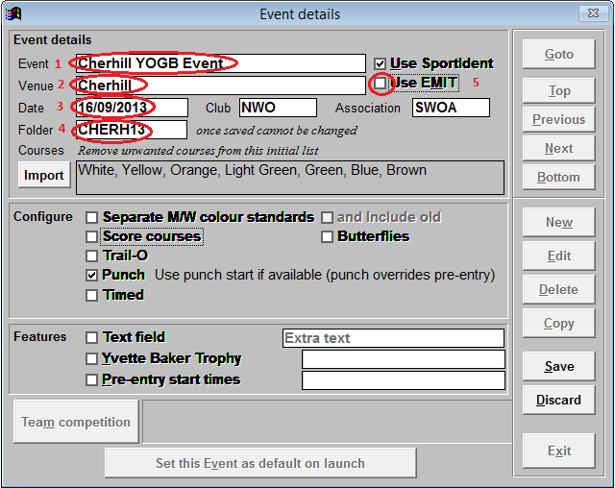
Enter
- Event Name
- Venue
- The event date
- The folder name will be generated automatically, but you can change it, e.g. if you have 2 Cherhill events in the same year.(Club and Association should already be filled)
- Select “Use Emit” and the following box will appear
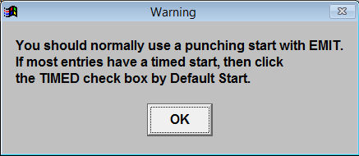
Since we normally use punching starts click OK.
Next edit the box with the list of courses
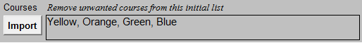
Note
Although the background is grey the text can be edited
Import button allows the courses to be imported from an IOF XML file exported from OCAD or similar.

Click Save and then click the large “Set this Event as default on Launch” button.
Click Exit to go back to main screen.

To add the controls for the courses click on Courses
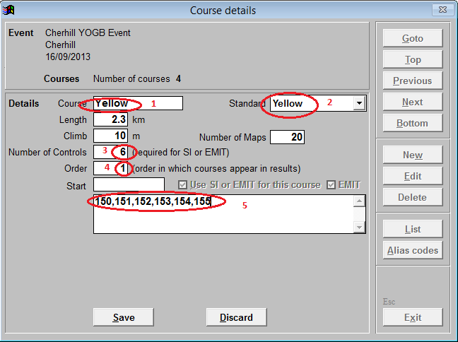
Check the event details at the top.
Enter
1. The Course this will be the first course you entered on the event screen
2. Select the course standard which is usually the same as the course name
3. Enter the number of controls on the course excluding start and finish
4. The order will usually be Y, O ,G , B, but you can use this number to reverse the order in the results.
5. Enter the controls in order, separated by commas. It is also possible to enter the order as 150-155, meaning 150 to 155 in numerical order or a mixture of single controls and runs of numbers e.g. 155,151-153,150
Length, Climb, Maps are optional
Click Save
Click Next
Repeat for the next course –Orange
Save and repeat for Green and Blue

If you enter the wrong number of controls you will get the following message when you save

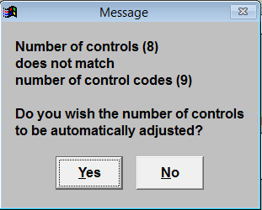
If you click Yes the number of controls will be set to the number you entered in the list
If you click No you will need to amend the control list
In both case you will need to click save again

You may get the following message if you click Yes
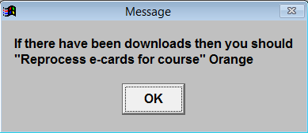
It can be ignored (unless you are modifying the course in the middle of download!)

If you want to see a list of the courses created
Click List
Click Preview (or Print or PDF as required)
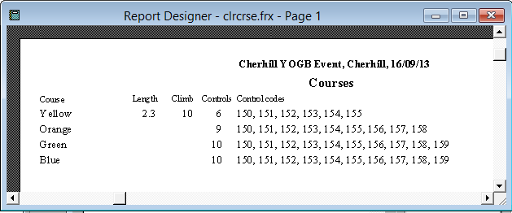
When courses are complete click Exit to return to main Screen and Exit again to close the program.
You have now completed the preparation and are ready for the event

Registration

On the day of the event boot the computer and follow the steps in
Running the encryption software
and
Running the Colour Software
Check that the correct event has been selected
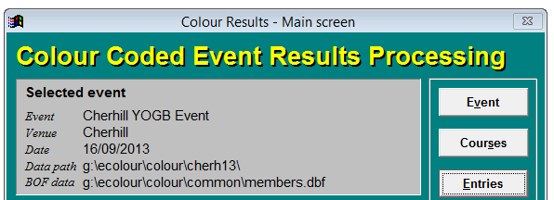
If not click on Event and use Next and Previous to find the event then Exit.
To start registration click on Entries.
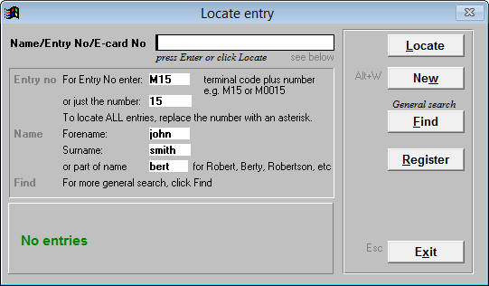
Click on Register (Click on OK on message about Fees)
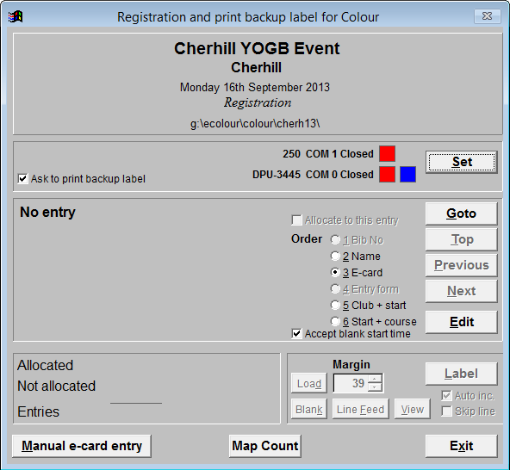
- Deselect “Ask to print backup label”
- Connect the reader to
Club PC nearest left USB port 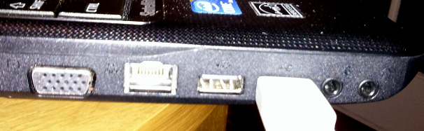C-
Martin’s Dell PC - left USB Port
Dell Inspiron Upper - left USB port

- Click on Set in order to connect the card reader.
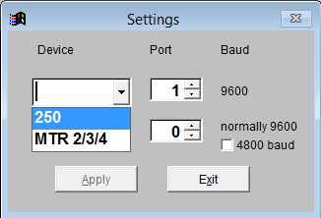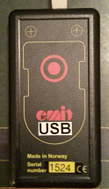

Select 250- this is the black box shown above. (or MTR2/3/4 if using the yellow reader)
Select the port number:
Club PC- 4
Martin’s Dell PC - 6
Dell Inspiron -

Click Apply
If you have correctly select the port the screen will show” 250 COM x Open” with a green box next to it.

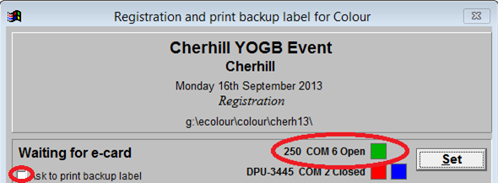

If the green box doesn’t appear e.g..
Click Set
Selct 250 again and select a different port number and apply .
Repeat until the box is green.

If it still doesn’t work
Ensure “ask to print backup label is not ticked” see screenshot above
Try a different USB port on the laptop.
Try restarting program
Try rebooting.

Once you have the green box you are ready to register people.

Case 1 Hired club EMIT card and knows BOF number

Club cards are blue marked with NWO and numbered 1 to 50
(They also have a unique 6 digit Emit number.)

Place the Emit card onto the card outline on the reader
A window will pop-up with the card number
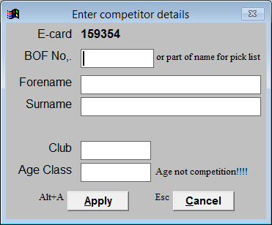

If the entrant knows their BOF membership number. Enter the BOF number
A window should show the following details
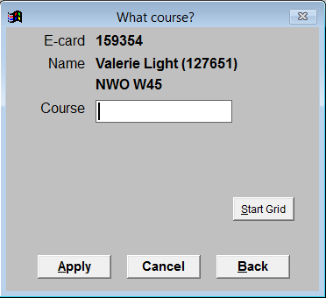
Check with the entrant that this the correct name !!!
Enter the Course name in the box and click Apply
Enter Yes when asked whether it is a hired e-card
The panel will show the entry details

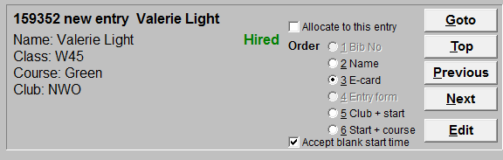

This assumes the entrant knows their BOF number.

Case 2 Hire card no BOF Number
If they do not know their number and are a member of BOF
Enter their surname instead of the BOF number e.g.
Click Apply and select the person from the BOF membership list
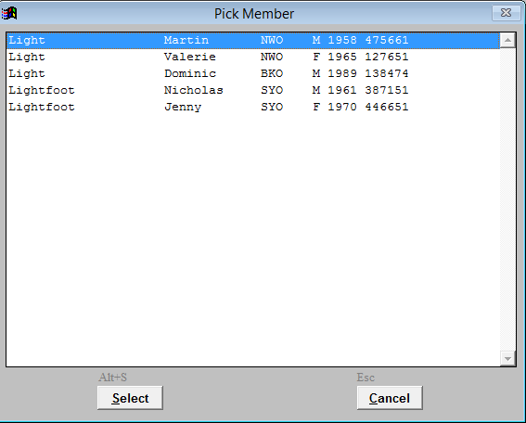
And click Select.

Case 3 Hired card not a BOF member
Instead of searching for the surname enter the details manually:
Forename, Surname, Club, Age Class
(If the entrant doesn’t belong to a club enter “IND” for independent.)

Case 4 Own Emit registered with BOF
Place the card on the reader and the following should pop up
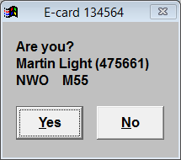
Check name with the entrant
If correct click Yes
If they have borrowed the card from someone else click No and fill in or details or search for the BOF number or Surname
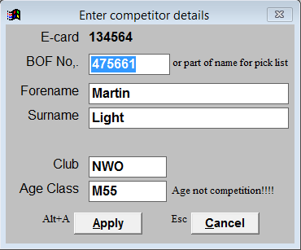
In both cases enter the Course on the next screen and click Apply
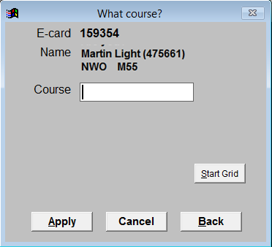

Case 5 Own EMIT card not registered with BOF
This is the same as registering someone with hire card.
This may occur because they have
- Only just bought the card
- Not registered the card with BOF
- The BOF database has not been updated on the laptop recently

Questions
Q What to do I do if I make a mistake !
A Use the Top, Previous and Next buttons to scroll through the list of entrants until you find the problem card/entrant
Alternatively Clicking on GoTo, which will allow you to search by card number or surname.
When you have found the problem card/entrant click Edit
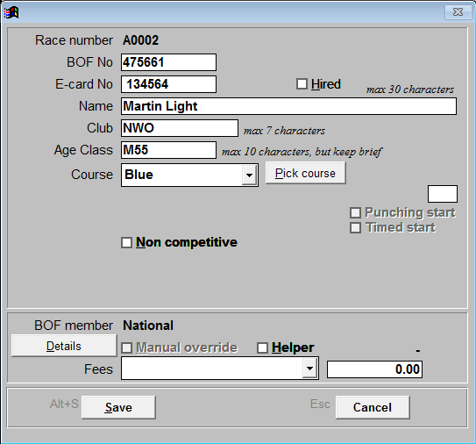
Amend the entry details and click Save or cancel to abandon the change
Q How do you delete an entry?
A I don’t know, I would change the name to “Deleted” and tick Non-competitive.
Q How can I tell how many people are on each course
A At the bottom of the registration screen there is a button labelled map count
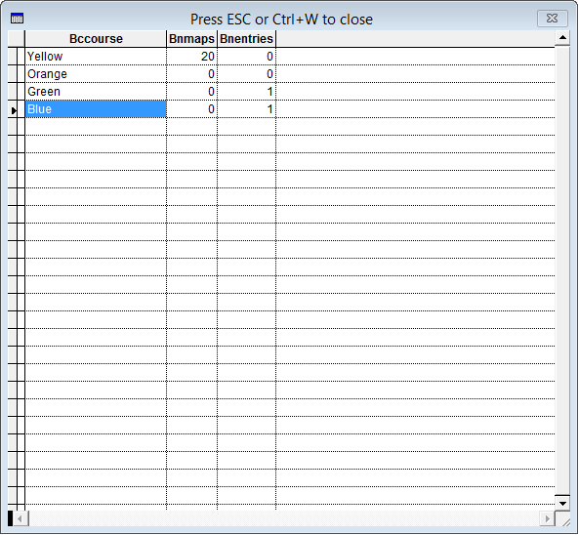
Press Esc or ctrl+W to close the Window (the X doesn’t work)

Download
It is possible to run the download at the same time as registration using 2 laptops and some networking.
I think it should also be possible to run 2 copies of the software each talking to a different reader using different USB ports, but I haven’t done enough experimenting.
With our current equipment I normally use the black box to register cards and then switch to download mode and use the yellow reader. This works OK if registration finishes before first finisher. If you have a few stragglers as registration you may have to switch back to registration mode,temporarily.
The yellow reader has advantages for download
- It will print splits
- It will store all the results in the event of computer failure
Plug in the reader to the port you used for registration
From the main Screen click on Results
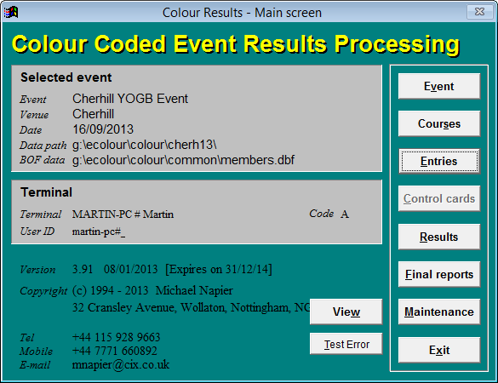
Plug the reader into the port used for registration.
In the case of the Yellow reader press “Clear on”
It should initially show batt and a number
It should eventually show the time in the upper window and ta95 in the lower window
Connect printer and switch it on left button (black)

This will bring up the results screen
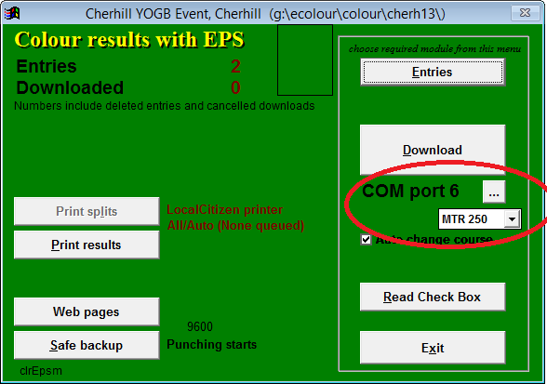
Click on the button … and enter the correct port number
Club PC- 4
Martin’s Dell PC - 6
Dell Inspiron -
Select “MTR 2/3/4” for the yellow box, MTR250 for the black box

Click on Download
If the reader is set up correctly the download page will look like: 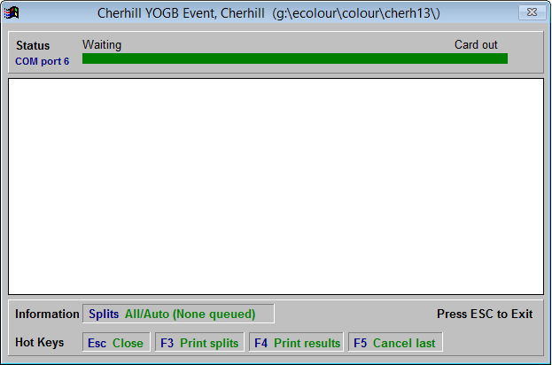
If the green bar doesn’t appear across the top press Esc and change the port number repeat until you get the green bar.
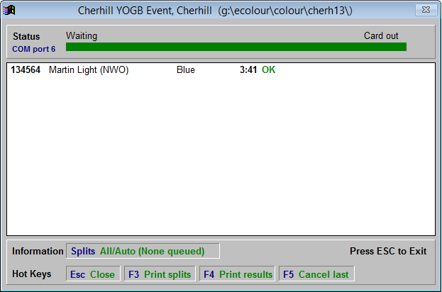
This shows that the runner finished in 3:41 did the blue course and the green OK shows he did all the controls
The printer should simultaneously print out the splits. If you are paranoid you can press “D Reprint e-card” to get a copy. (F3 and F4 print options require separate split and results printers.)
Next finisher has not completed their course
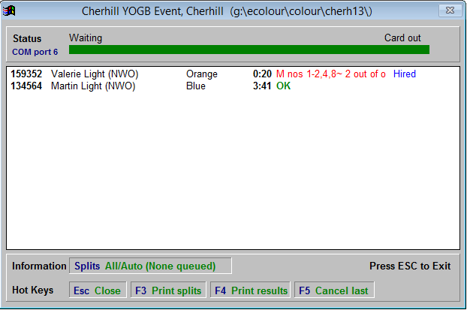
The display shows controls missed and out of order
When finished or you need to go to other menu option press Esc
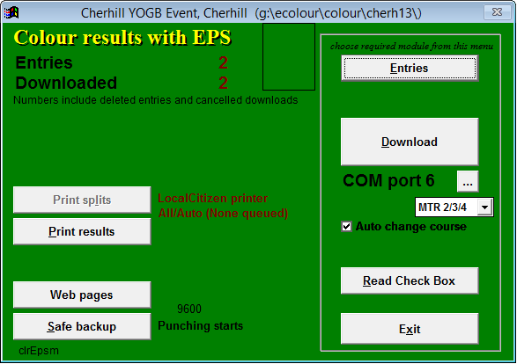

Other Options from this menu

1 Print Results
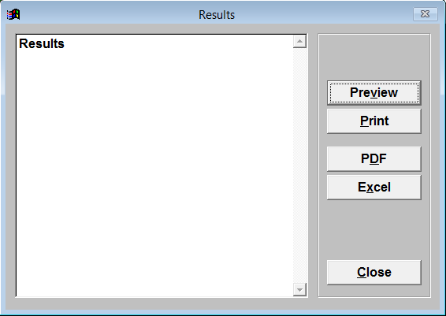
Preview - Displays results on screen
Print - Currently has no action since we don’t have a printer
PDF – Requires additional software
Excel – Creates an EXCEL file

2 Web Pages
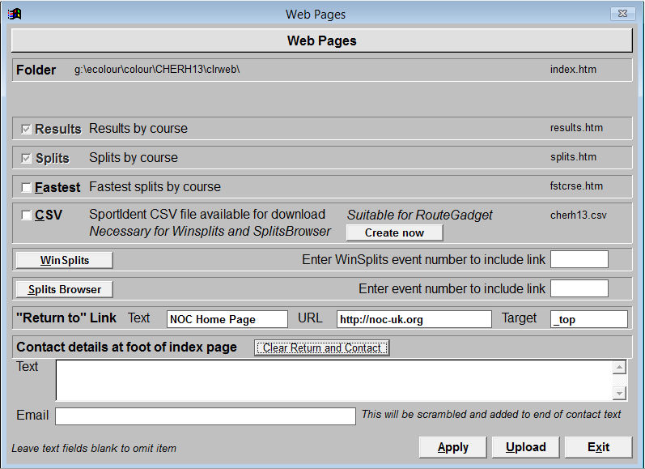
Click apply will create results.htm and splits.htm suitable for the website
Selecting CSV and clicking Create Now will generate a file suitable for RouteGadget
The Winsplits and SplistsBrowser buttons take you to their websites - not useful
Upload requires additional software.

3 Read Check Box
We don’t have a check box

4 Entries
Takes you to the Locate Screen.

Locate Screen
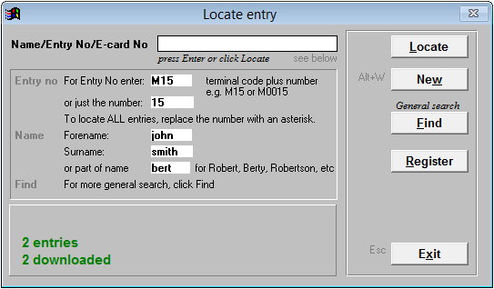
This has several useful functions
- Locate
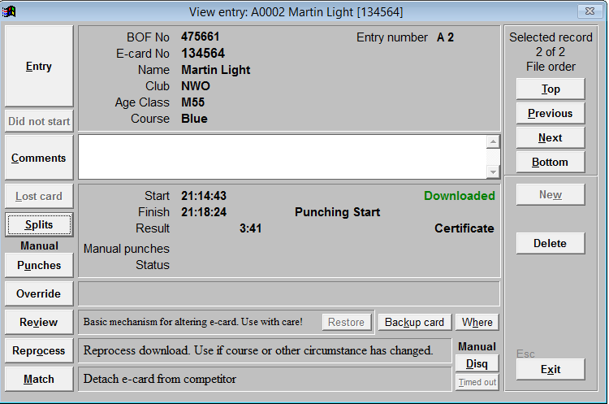
This screen allows you to scroll through the runners using the right hand buttons
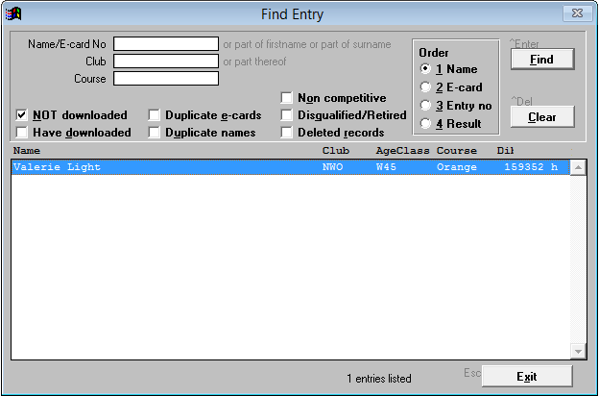
Left hand buttons allow you to edit the time, add manual punches , view splits and other details or to disqualify or delete.
- Find
Left hand buttons allow you to edit the time, add manual punches , Find allows you to list competitors by various categories. One of the most useful is to find who is still out on the course:
Select “Not Downloaded” and click Find.

Score Events

To create a Score event or mixed Score and Colour event ; tick score vent on the Event details page.
This in the configure area when creating an Event.
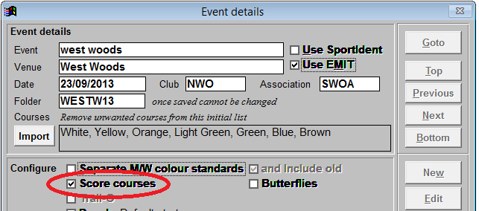
This will add additional options when creating each course.
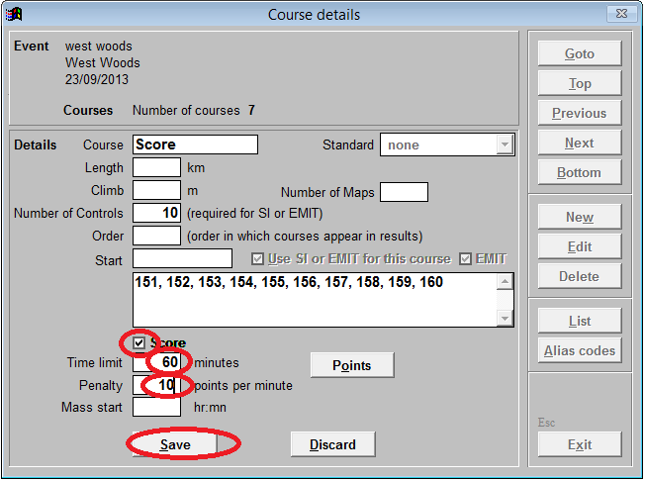
For each score course :
Tick Score
Enter the time limit
Enter the points penalty
Click Save
Click Points – NB you must click Save first
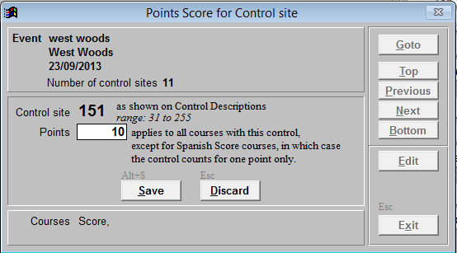
Enter the points for the first control number and click Save
Click Next and repeat for all the controls on the course
If you have more than Score course e.g.. a Junior or novice score course repeat for these courses.

